Updated the code in **test.py** file

python test.py --i ca_clayton_2022.xlsx --o ca_clayton_2022.html

This above line is used to run the script .

**Input files:**

1. **ca_clayton_2022.xlsx** - Excel file which has the financial reports
2. **Xbrl Independent Auditor.docx** - Sample word Document
3. **contexts.xlsxf**

**Expected Output:**

This will append the word content in the xbrl format

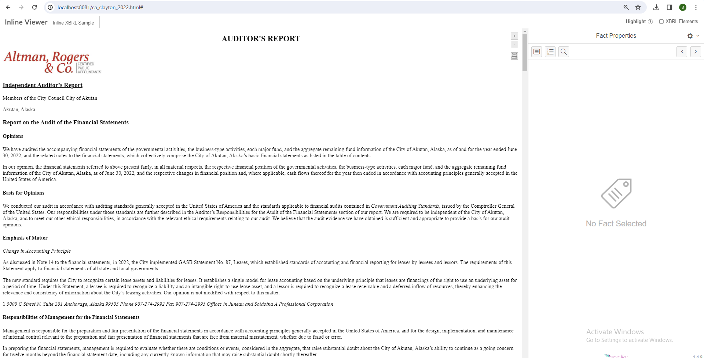

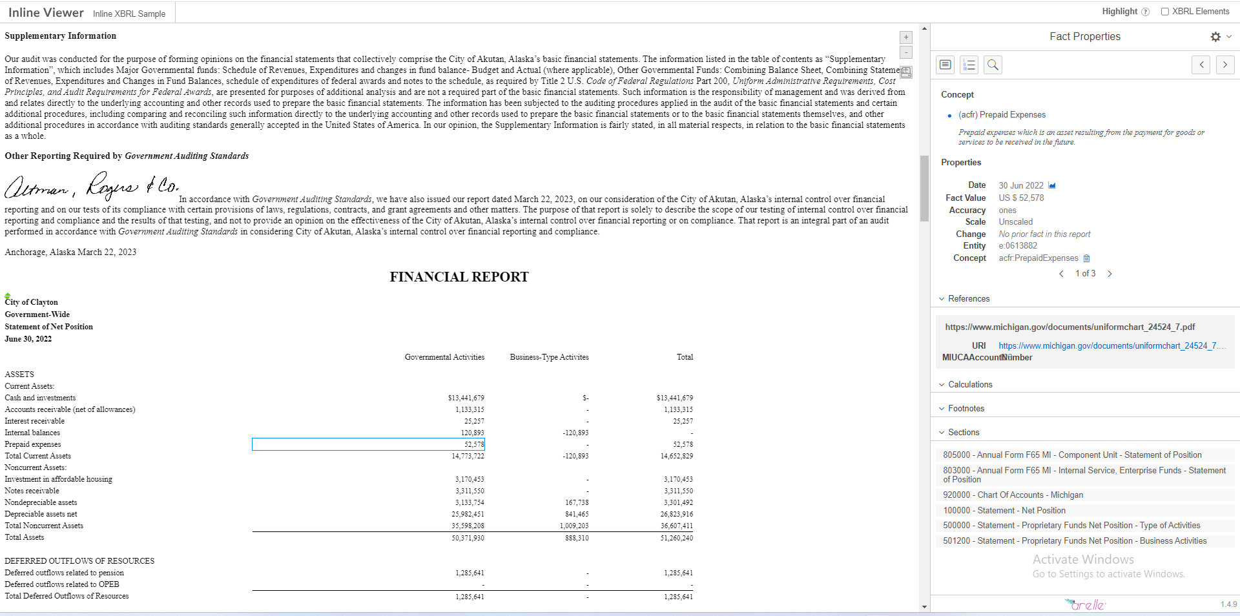

[give the sample input file]

word_file_path = 'Xbrl Independent Auditor.docx'

from docx2python import docx2python

def extract_text_from_docx(file_path):

[Extract the content using docx2python library]

doc_html_result = docx2python(file_path, html = True)

text_content = ""

for page in doc_html_result.body[0][0][0]:

for paragraph in page:

for element in paragraph:

if not isinstance(element, dict) or ('type' in element and element['type'] != 'footer'):

if isinstance(element, str):

text_content += element

text_content += '\n'

doc_html_result.close()

return text_content

word_text = extract_text_from_docx(word_file_path)

html_in += soup.prettify("utf-8").decode("utf-8")

[Removed the unusual font size in the word content]

word_text = re.sub(r'style="[^"]*"', '', word_text)

[Added the function for insert the line spacing for the paragraph content]

def add_paragraph_tags(html_input):

soup = BeautifulSoup(html_input, 'html.parser')

for line in soup.find_all(string=True):

if line.strip() and line.parent.name not in ['h3','h4','span','b','u','i']:

paragraphs = line.strip().split('\n') # Split text into paragraphs based on double newlines

for paragraph in paragraphs:

p_tag = soup.new_tag("p")

p_tag.string = paragraph.strip()

line.insert_before(p_tag) # Insert the <p> tag before the current line

line.insert_before("\n") # Add a newline after the <p> tag for formatting

line.extract()

return str(soup).replace('</p><i>','<i>').replace('</p>\n<i>','\n<i>').replace('</i><p>','</i>')

word_text = add_paragraph_tags(word_text)

from docx import Document

[Used this Document library to get the image from the word document]

def extract_images(docx_file):

doc = Document(docx_file)

images = []

for rel in doc.part.rels.values():

if "image" in rel.reltype:

image_data = rel.target_part.blob

image_name = rel.target_ref[:] # Get the image name

images.append((image_name, image_data))

return images

images = extract_images(word_file_path)

for idx, (image_name, image_data) in enumerate(images):

with open(f"{image_name}", "wb") as f:

f.write(image_data)

[ Used this function for replace the image with image name ]

def replace_image_placeholders(content):

pattern = r'----(.*?)----'

replaced_content = re.sub(pattern, r'<img src="\1" style="width:300px;" />', content)

return replaced_content

word_text = replace_image_placeholders(word_text)

[ added a header “**AUDITOR'S REPORT”** and the word content]

ix_header = conf.ix_header_start + ix_header_content + conf.ix_header_end + '<ix:nonNumeric> \n <h2 align="center"> AUDITOR\'S REPORT </h2> '+ word_text+'</ix:nonNumeric>'

[ added a header **“FINANCIAL REPORT”** before the excel content]

html_out = conf.new_header + '\n' + ix_header.replace("$place_id$", conf.place_id) + '\n<ix:nonNumeric> \n <h2 align="center"> FINANCIAL REPORT </h2> </ix:nonNumeric>'

for line in html_in.splitlines():

html_out = html_out + line + '\n'

html_out = html_out +'</body></html>'

html_out = html_out.replace("&lt;", "<")

html_out = html_out.replace("&gt;", ">")

html_out = html_out.replace("xbrli:startdate", "xbrli:startDate")

html_out = html_out.replace("xbrli:enddate", "xbrli:endDate")

os.remove("temp0")

os.remove("temp")

encoded_html_out = html_out.encode('utf-8')

decoded_html_out = encoded_html_out.decode('utf-8') # Decode the encoded string using UTF-8 encoding

[ The html file (Word content + Excel content) will be saved as output_file (--o file_name which we gave while run the script) ]

with open(output_file, 'w', encoding='utf-8') as f:

f.write(decoded_html_out)

print(f"Successfully converted to {output_file}")